Assignment Description
Complete the following steps from page 1452:
- Programming Exercise 1: Write a program that outputs the nodes of a graph in a depth-first traversal.
- Programming Exercise 2: Write a program that outputs the nodes of a graph in a breadth-first traversal.

1 Readme Documentation
This program contains a graph class which can store nodes, edges between nodes, and outputs the nodes in depth first and breadth first order.

2 Flowchart Screen Shots

3 UML and Use Case Diagrams
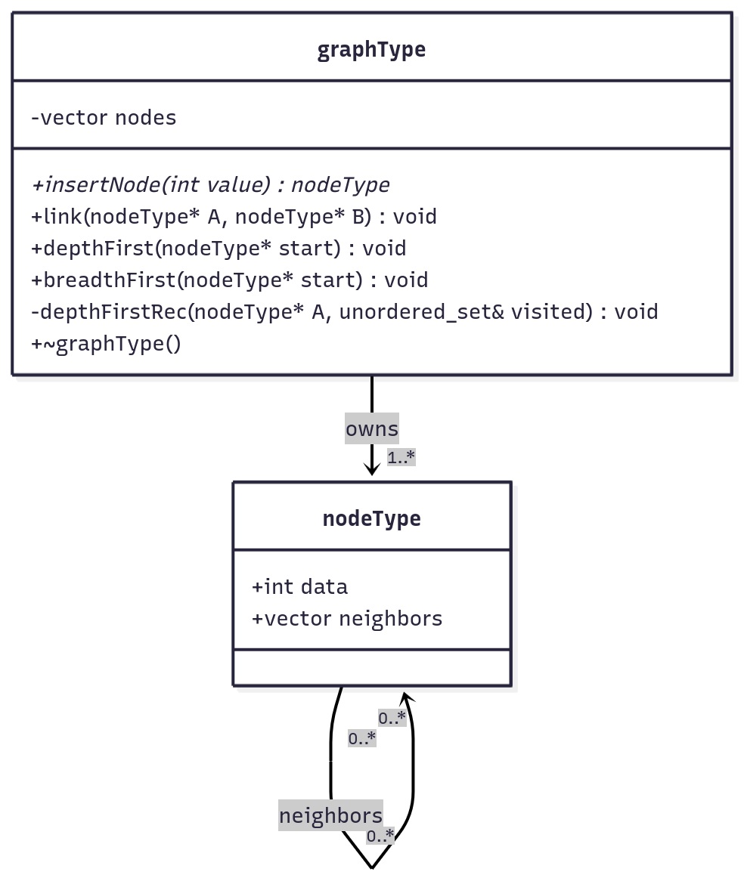

4 Source Code of All files (.h, .cpp)
#include <iostream>
#include <vector>
#include <unordered_set>
#include <queue>
#include <algorithm>

struct nodeType{
int data;
std::vector<nodeType*> neighbors;
};

class graphType{
private:
std::vector<nodeType*> nodes;

void depthFirstRec(nodeType* A, std::unordered_set<nodeType*> &visited){
if(!A || visited.count(A)) return;

visited.insert(A);

std::cout << A->data << ' ';

for(nodeType* node : A->neighbors){
depthFirstRec(node, visited);
}
}

public:
nodeType* insertNode(int value){
nodeType* newNode = new nodeType;
newNode->data = value;

nodes.push_back(newNode);

return newNode;
}
void link(nodeType* A, nodeType* B){
if(std::find(A->neighbors.begin(), A->neighbors.end(), B) != A->neighbors.end()) return;

A->neighbors.push_back(B);
B->neighbors.push_back(A);
}

void depthFirst(nodeType* start){
std::unordered_set<nodeType*> visited;
depthFirstRec(start, visited);
}

void breadthFirst(nodeType* start){
std::unordered_set<nodeType*> visited;
std::queue<nodeType*> nodeQueue;

nodeQueue.push(start);
visited.insert(start);

while(!nodeQueue.empty()){
nodeType* node = nodeQueue.front();
nodeQueue.pop();

std::cout << node->data << ' ';

for(nodeType* neighbor : node->neighbors){
if(!visited.count(neighbor)){
visited.insert(neighbor);
nodeQueue.push(neighbor);
}
}
}

}
~graphType(){
for(nodeType *node : nodes){
delete node;
}
}
};

int main(){
graphType graph;

nodeType* A = graph.insertNode(1);
nodeType* B = graph.insertNode(2);
nodeType* C = graph.insertNode(3);
nodeType* D = graph.insertNode(4);
nodeType* E = graph.insertNode(5);
nodeType* F = graph.insertNode(6);

graph.link(A, B);
graph.link(B, C);
graph.link(C, D);
graph.link(B, D);
graph.link(C, F);
graph.link(A, F);
graph.link(E, C);

std::cout << "Breadth first:" << std::endl;
graph.breadthFirst(A);

std::cout << std::endl << "Depth first:" << std::endl;
graph.depthFirst(A);

std::cout << std::endl;

return 0;
}

5 Three Use Case Screen Shots
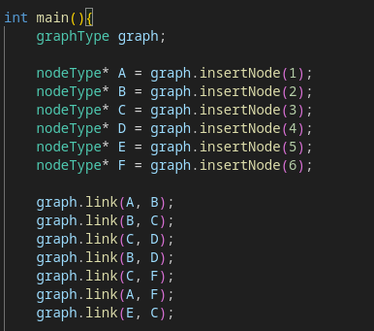
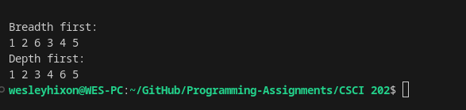

(Optional) GitHub URL

